**UI Design and Prototyping**

### **Project Title**

1. Introduction.
2. User Interface Design and Prototype.
3. Navigation Structure.
4. References.
5. **Introduction to the platform.**

**The main idea** of the platform is to improve conversational skills. The learning platform can help you improve your English by connecting with people with the same goal.

**The value** of the web application is not the study of grammar, but communication with people, curiosity to learn something new from people from all over the world. It's like a social network for people who want to break the barrier of misunderstanding and fear of speaking.

All the user needs is to have basic speaking and comprehension skills (approximately A-2 – B-1 lvl).

1. **User Interface Design and Prototype**

**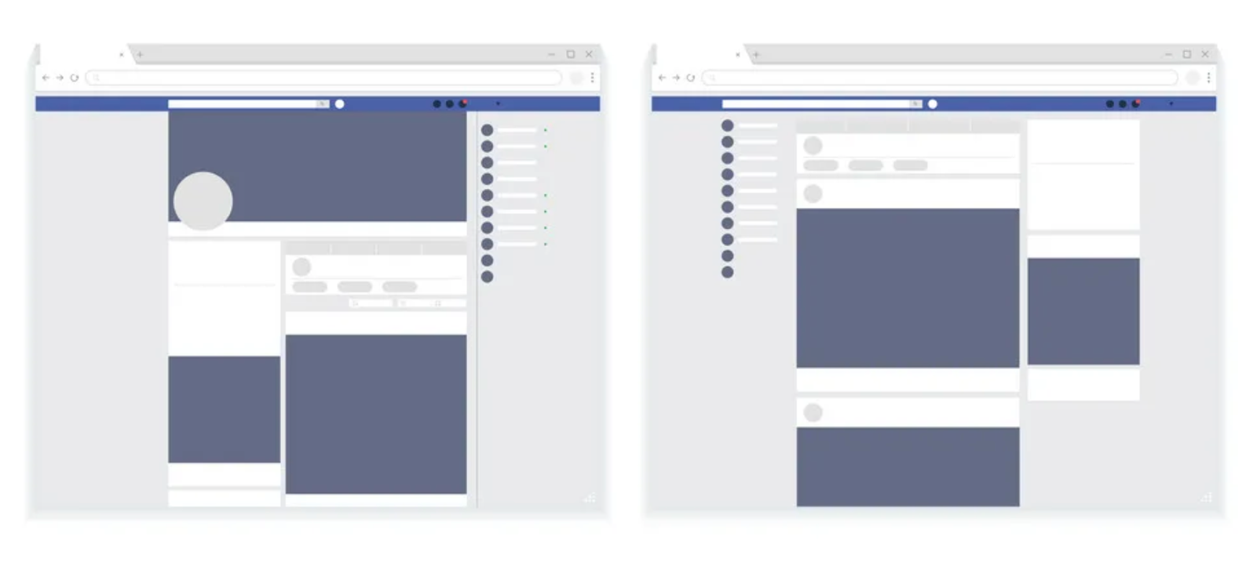**

1. **Navigation Structure.**

The structure of my application looks like a mixture of social networks and most of the video chat.

* The user is prompted to create a profile before entering the site
* Search for an available partner by interest tags
* Video call with a partner or audio messaging
* Network development

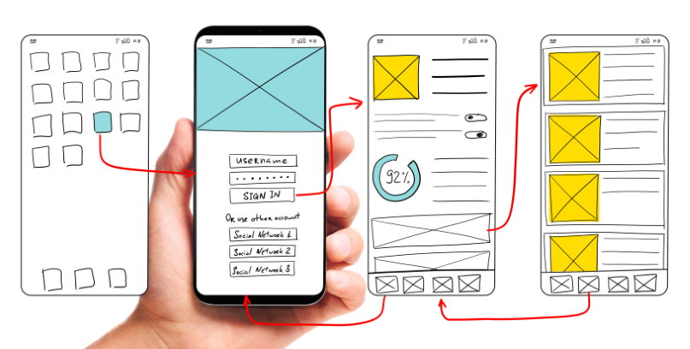

1. **References**

**The Nation’s English-Learner Population Has Surged: 3 Things to Know:**

The report tracks enrollment from the 2000-01 school year to the 2016-17 school year, the latest year for which numbers are available and provides a quick look at national demographic trends.

<https://www.edweek.org/leadership/the-nations-english-learner-population-has-surged-3-things-to-know/2020/02>

**How many people learn English?**

There are 1.5 billion English-language learners worldwide, says [British Council](http://www.britishcouncil.org/organisation" \t "_blank) member John Knagg. The group is one of the largest providers of English language instruction in the world with more than 3,000 full-time English teachers globally. The number of English-language learners has led to a great demand for those who can teach the language, Knagg says, adding: "The lack of qualified English language instructors presents one of the largest challenges to educators and citizens across the globe."

**By Kenneth Beare**

**Updated on November 18, 2019**

<https://www.thoughtco.com/how-many-people-learn-english-globally-1210367>

**Number of students learning English as a foreign language in 2020, by country**

<https://www.statista.com/statistics/474379/english-language-students-per-country/>

**Conclusion**

Briefly compare the app features above with my app idea. The advantage of my application is the free use of a certain number of minutes per month, the ability to create a social network and communicate with people at any time and most importantly, break the wall of fears to speak English with people.